RabbitMQ is an open-source message broker that allows different software components or microservices to communicate with each other asynchronously. [1, 2]
Instead of two applications talking directly to one another, they send and receive messages through RabbitMQ, which acts like a digital post office. It is developed in Erlang and officially supported by Broadcom. [1, 2, 3, 4, 5]

Key Core Concepts
- Producer: The application or service that creates and sends a message.
- Exchange: The "brain" that receives messages from producers and routes them to queues based on rules and routing keys.
- Queue: The buffer that stores messages safely until a consumer picks them up.
- Consumer: The application or service that reads and processes the message from the queue.
- Binding: The link or rule connecting an exchange to a queue. [1, 2, 3, 4]
Common Exchange Types
- Direct Exchange: Routes messages to a queue that matches an exact routing key.
- Fanout Exchange: Broadcasts every message to all queues bound to it (useful for alerts or broadcasts).
- Topic Exchange: Routes messages to queues based on wildcard pattern matching on the routing key.
- Headers Exchange: Routes messages based on header attributes instead of routing keys. [1]
Why Use RabbitMQ?
- Decoupling: Services do not need to know where the other service is or if it is currently online. If a worker goes down, messages wait safely in the queue. [1, 2, 3, 4]
- Asynchronous Processing: Heavy tasks (like generating a PDF, resizing an image, or sending batch emails) can be handed off to background workers so web pages load instantly for users. [1, 2]
- Reliability: Supports message acknowledgments, persistence, and dead-letter queues to ensure tasks are not lost during server crashes. [1, 2]
- Protocol Support: Primarily implements AMQP (Advanced Message Queuing Protocol), with plug-ins for MQTT, STOMP, and more.

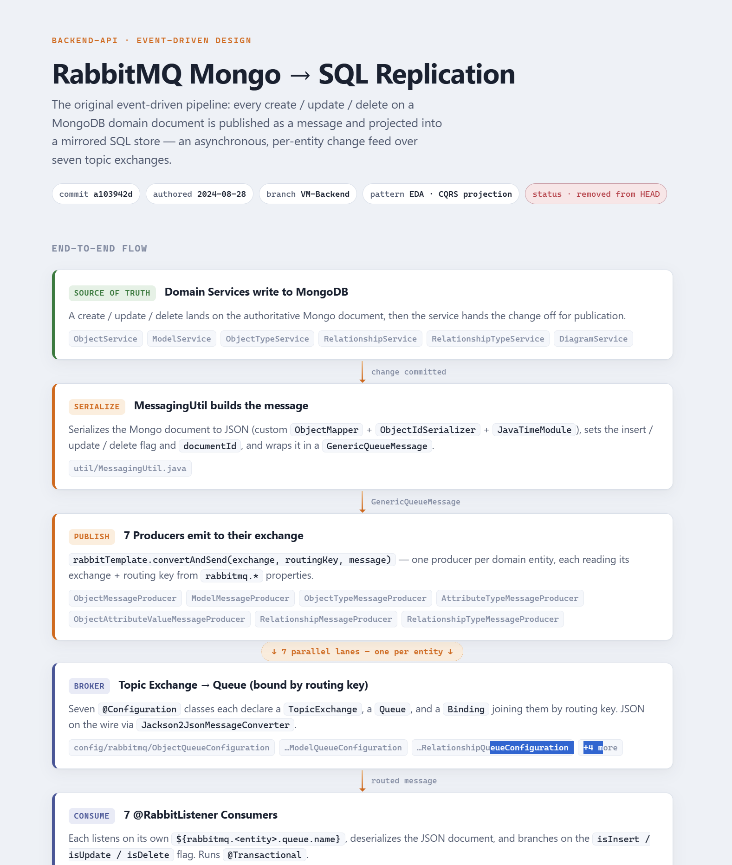
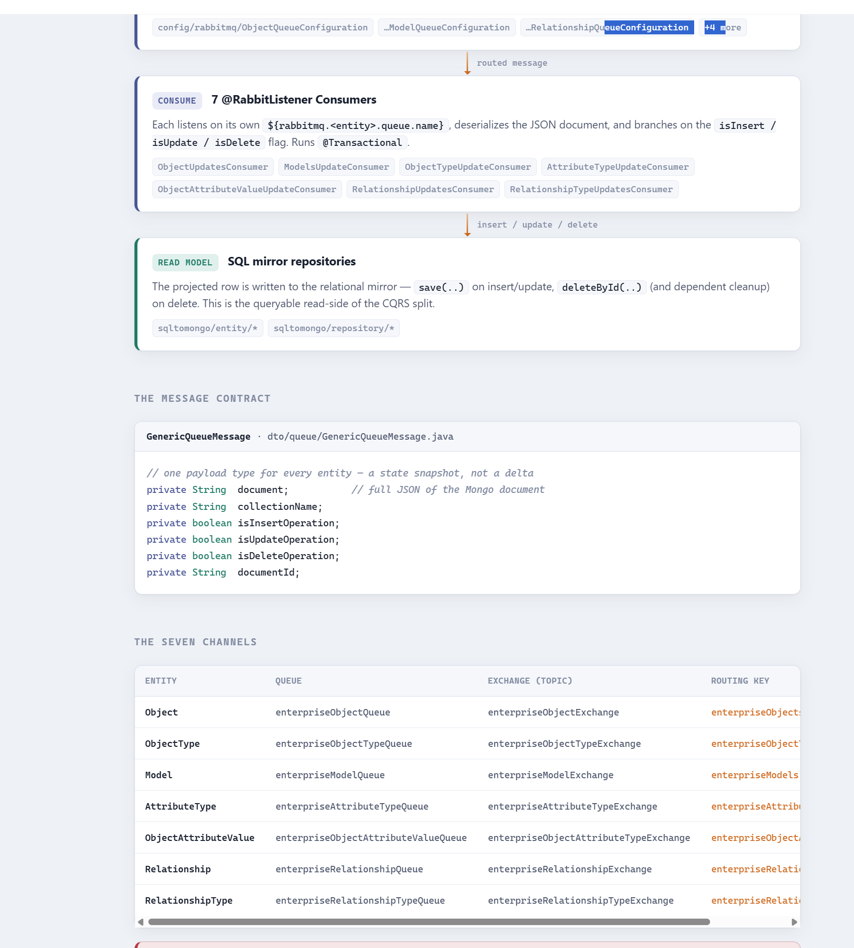
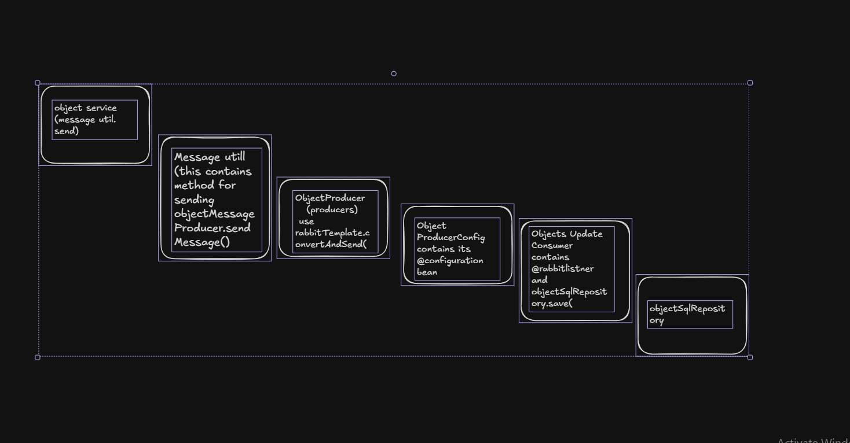
rabbit mq mostly asked questions
1. Core Concepts & Architecture
- What is RabbitMQ and why is it used?
Medium
  - Answer: RabbitMQ is an open-source message broker (written in Erlang) that implements the AMQP (Advanced Message Queuing Protocol). It is used to decouple applications, handle asynchronous communication, buffer spikes in traffic, and ensure reliable message delivery across distributed microservices.
Java Guides+ 1
- Can you explain the basic architecture of RabbitMQ?
Medium
  - Answer: The core components are:
    - Producer: The application that sends/publishes messages.
Medium
    - Exchange: Receives messages from producers and routes them to queues.
CloudAMQP
    - Queue: A buffer that stores messages until consumers process them.
CloudAMQP
    - Binding: A rule/link that connects an exchange to a queue.
Second Talent
    - Consumer: The application that receives and processes messages from the queue.
CloudAMQP
- What is the difference between a Connection and a Channel?
  - Answer: A Connection is a heavy, long-lived TCP connection between your application and the RabbitMQ broker. A Channel is a lightweight "virtual connection" inside that TCP connection. Multiplexing channels over a single connection avoids the overhead of opening/closing TCP connections constantly.

2. Routing & Exchanges
- What are the different types of Exchanges in RabbitMQ?
Medium
  - Answer: There are four main built-in exchange types:
Second Talent
    - Direct: Routes messages to queues based on an exact match between the message's routing key and the binding key.
Medium
    - Fanout: Broadcasts messages to all queues bound to it, ignoring routing keys.
Second Talent
    - Topic: Routes messages based on wildcard matches (* for a single word, # for zero or more words) against a dotted routing key.
Medium
    - Headers: Uses message header attributes instead of routing keys for routing.
Second Talent
- What happens to a message that matches no queue?
Second Talent
  - Answer: By default, the message is silently dropped. To prevent this, you can set the mandatory flag on publish (which returns an unroutable message back to the producer via basic.return) or configure an Alternate Exchange (AE).
Second Talent+ 1

3. Reliability & Message Delivery
- How do you ensure a message is never lost (Reliable Delivery)?
Second Talent
  - Answer: To guarantee end-to-end reliability, you must secure every hop:
    - Publisher Confirms: The broker acknowledges to the producer that it has successfully received and saved the message.
Second Talent
    - Durable Queues & Persistent Messages: Declare queues as durable and set messages as persistent (delivery_mode = 2) so they survive a broker restart.
Second Talent
    - Consumer Acknowledgments (Acks): Consumers send manual acks back to RabbitMQ only after successfully processing a message, ensuring it isn't lost if the consumer crashes mid-way.
Second Talent
- What is a Dead Letter Exchange (DLX)?
Medium
  - Answer: A DLX is a safety net exchange where messages are redirected if they fail processing. Messages are "dead-lettered" under three conditions:
    - They are explicitly rejected or negatively acknowledged (basic.reject or basic.nack) with requeue=false.
    - They expire (TTL elapsed).
    - The queue reaches its maximum length limit.
- What is Prefetch Count (basic.qos), and why is it important?
Second Talent
  - Answer: Prefetch limits the number of unacknowledged messages RabbitMQ will push to a single consumer at one time. Setting a prefetch limit (e.g., 1) ensures fair workload distribution among multiple consumers, preventing one fast consumer from hogging all messages while others sit idle.
Second Talent+ 1

4. Scaling & Advanced Operations
- What is the difference between Classic Queues and Quorum Queues?
  - Answer: Classic queues are traditional queues (can be mirrored across nodes, though mirroring is deprecated in newer versions). Quorum queues are modern, highly available, consensus-based queues built on the Raft protocol. They offer safer, automatic replication and data safety out-of-the-box, making them the production standard for reliable queues.
- How does RabbitMQ handle high memory or disk space usage (Flow Control)?
Medium
  - Answer: RabbitMQ has built-in alarm mechanisms. If memory consumption or disk space crosses a specific high-watermark threshold (e.g., running low on disk space), RabbitMQ triggers a flow control state that blocks publishers from sending more messages until the system frees up resources, protecting the broker from crashing.
- When should you choose RabbitMQ vs. Apache Kafka?
  - Answer:
    - Choose RabbitMQ for complex routing logic, task-queue workloads, fine-grained message tracking, low latency for individual messages, and when messages should be deleted immediately after successful processing.
    - Choose Kafka for high-throughput event streaming, log aggregation, event-sourcing, and scenarios where multiple independent consumers need to replay historical data streams multiple times.

